**ASSIGNMENT-19.2:**

Convert XML File into Json File Format

You can consider below example XML, save it in the hdfs cluster and then to convert into Json File Format. Share the codes used with the screenshot for the same.

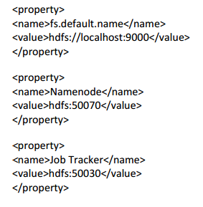

Input File:

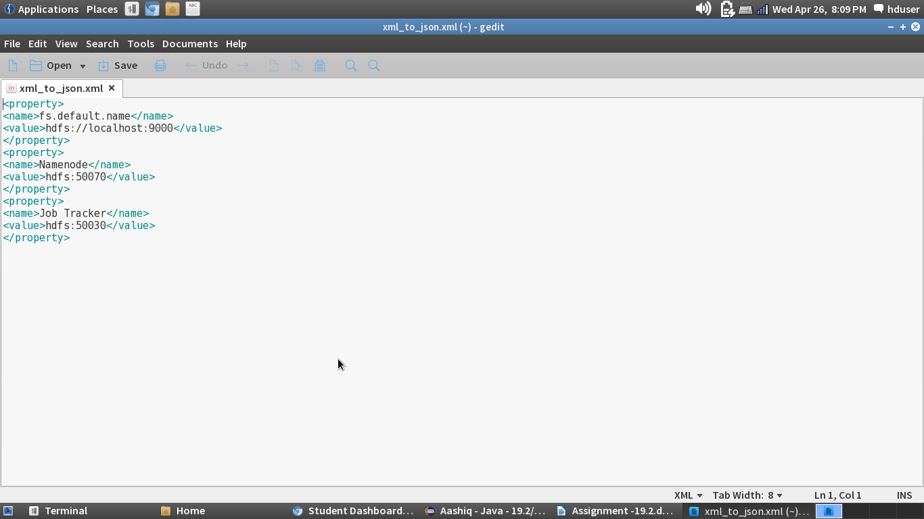

CLASS :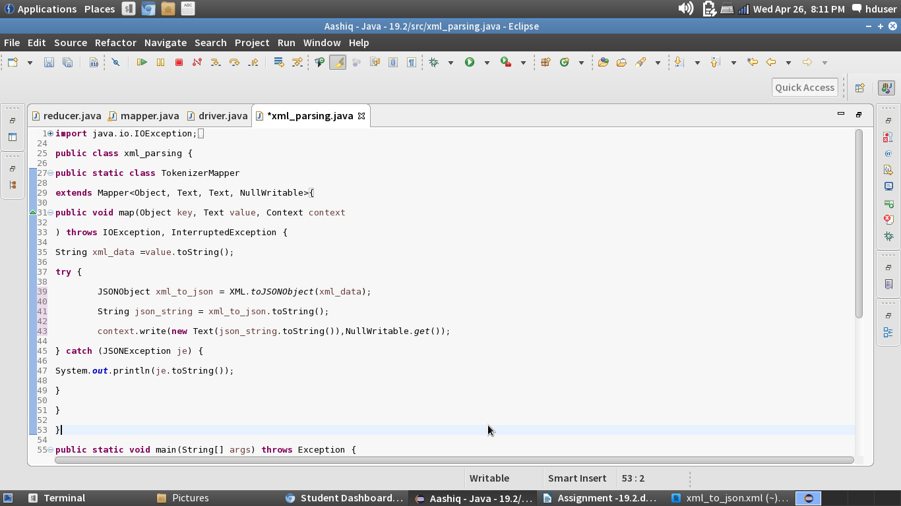

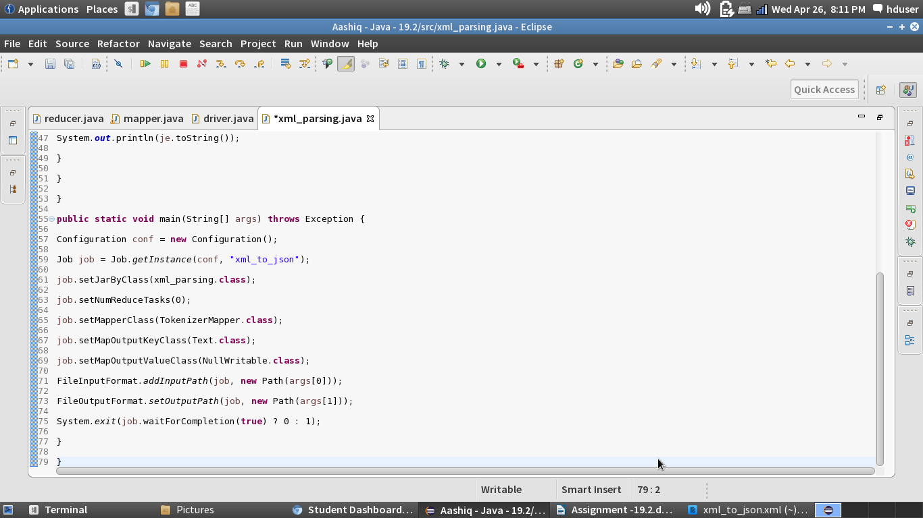

Running the Jar File:

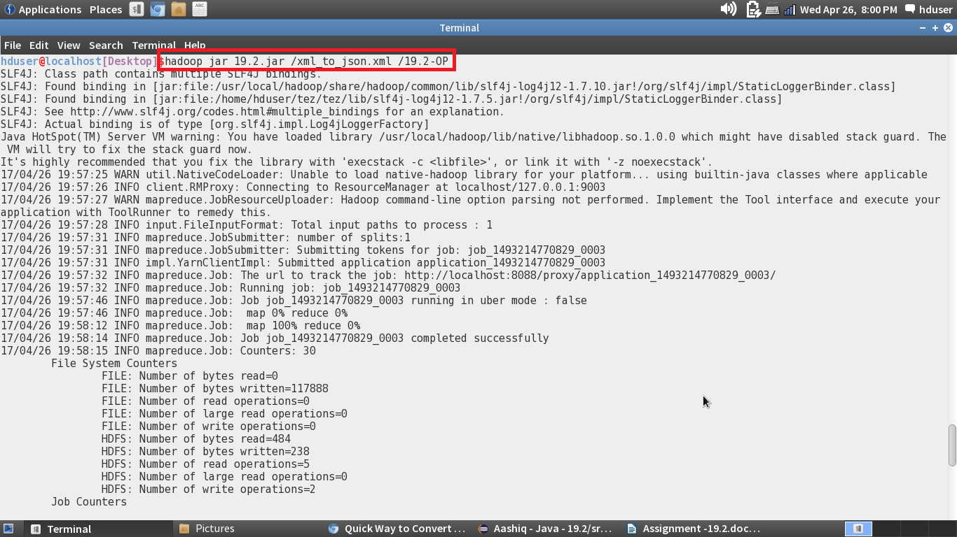

Output File:

